7.1.1 SAFETY AND SECURITY
COLLEGE ENTRANCE C C CAMERA

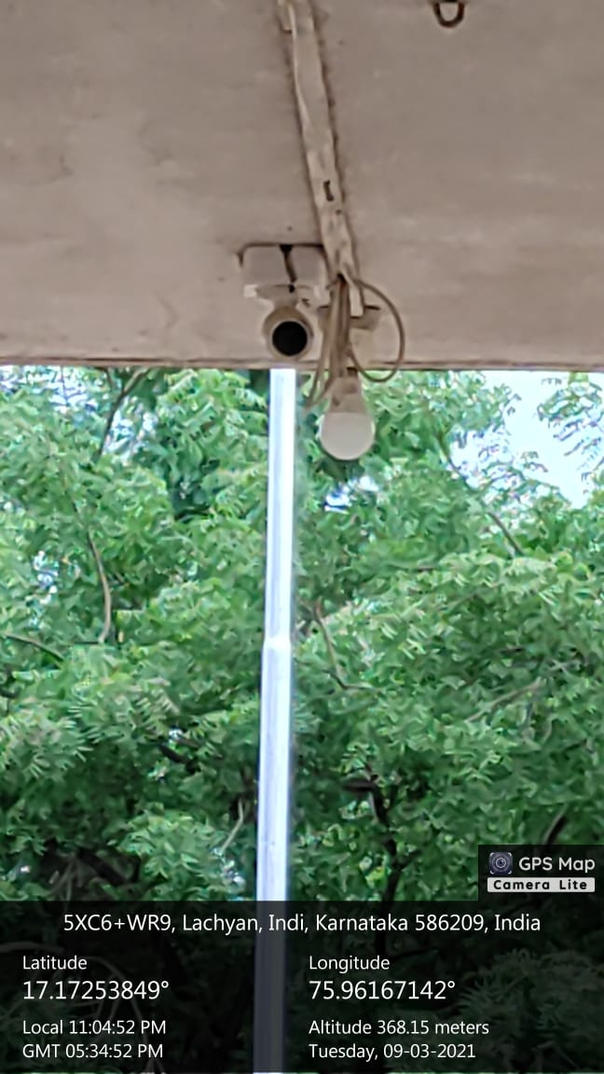

CHEMISTRY LAB C C CAMERA

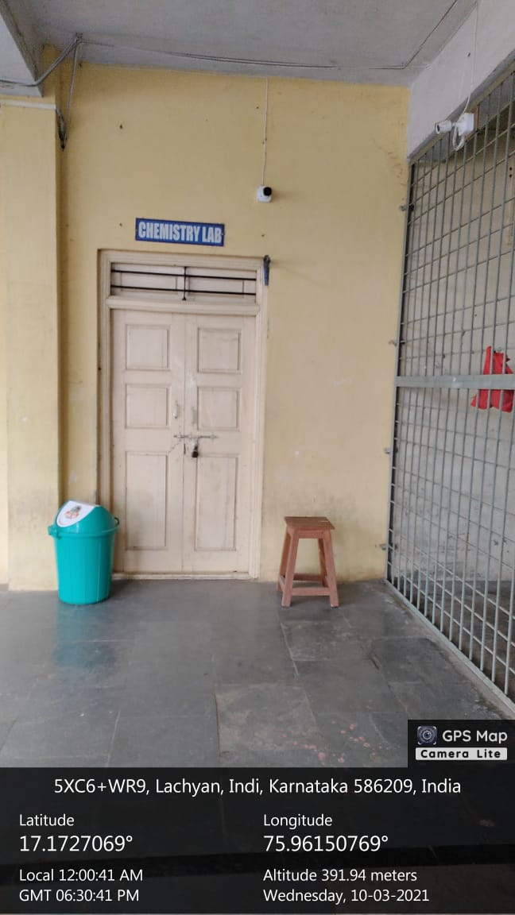
COMPUTER LAB C C CAMERA

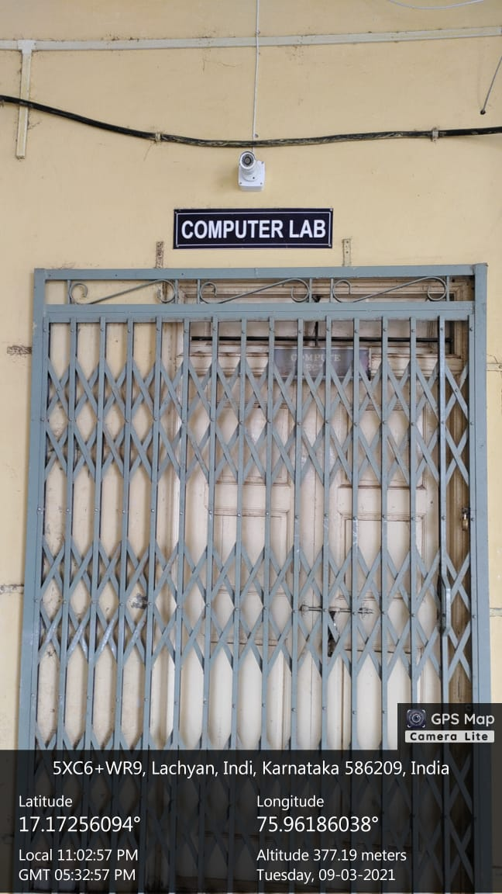

COMPUTER LAB
